Comments to be fixed VCDA Enhanced Portal – July 25, 2025

Comments on Login

- I cleared cache and tested in incognito mode and still have the same issue as listed before. Below are the issues
  - When on click on signin it takes me to the azure login page. I use my afdb email and password and sign in (s.jagannathan@afdb.org)
  - It takes me to this page
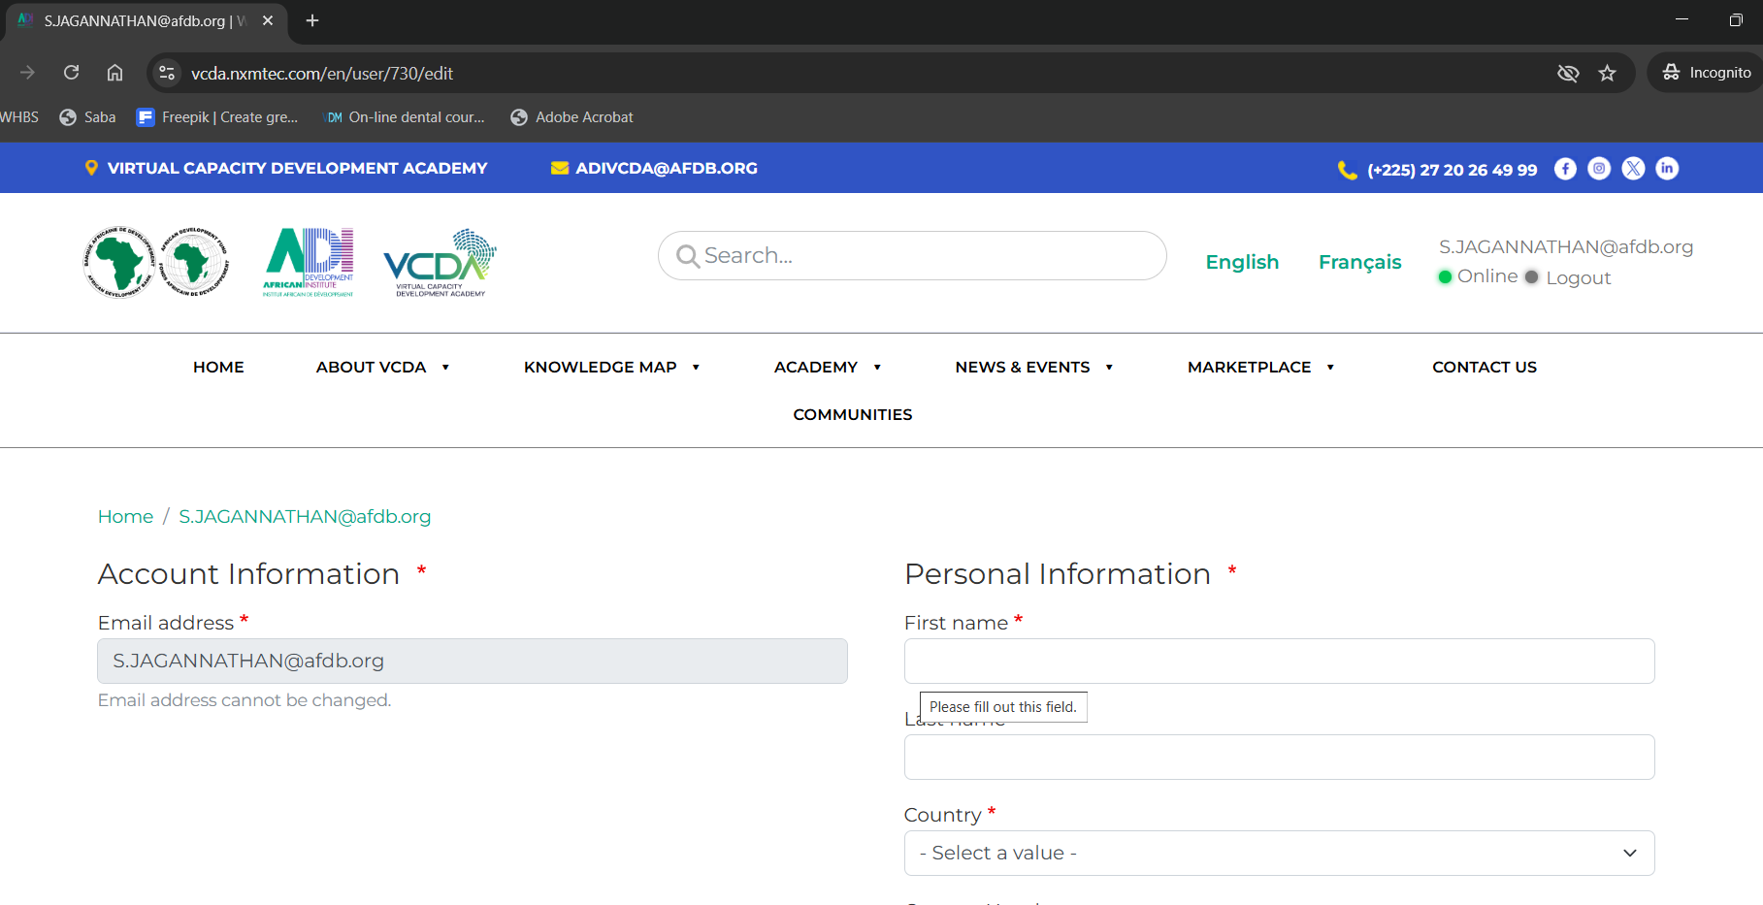
  - My first name and last name is not displayed and it asks me to complete this page with all the details.
  - After I fill in all the details submit it show the below error message: The value you selected is not a valid choice.
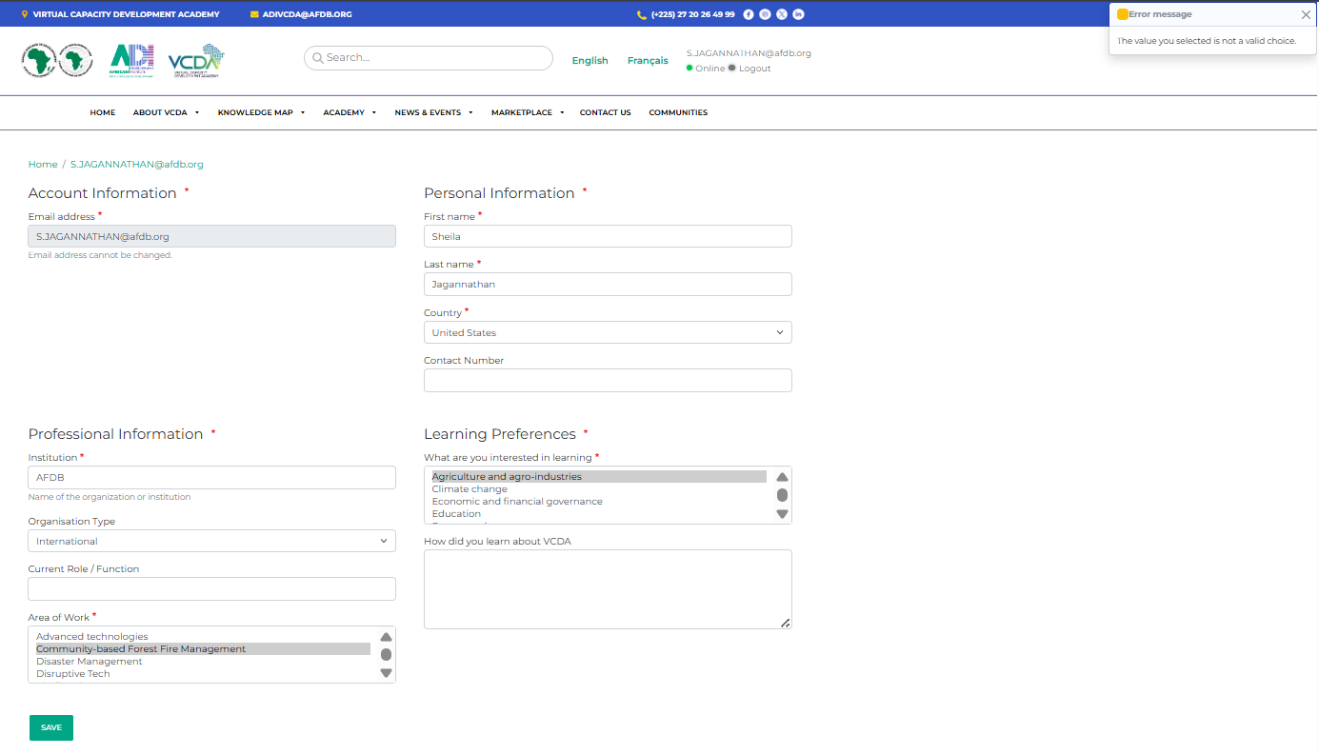
  - Even if I try to change the values it gives the same error
  - I think the page is expected to pull the details of First Name, Last name and country from my afdb account and not allow me to enter it here.
- Earlier I assumed it wouldn’t allow me to access other pages until I complete this but that is not the case. I am able to access the other pages and so I have include the report form other testing also below
Comments on Academy page

- The course catalog looks good. The green label should the type of course and not the category of the course. (Self-paced, Facilitated, Blended) etc., should should displayed in the green label and not the category as it is displaying now. Please fix.
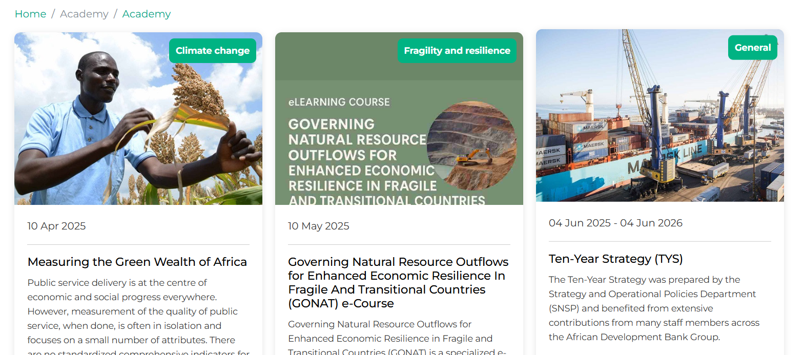
- Search works well.
- When after login I access the catalog the overall site head and footer is not displayed. Only the catalog section is displayed. Please check and fix

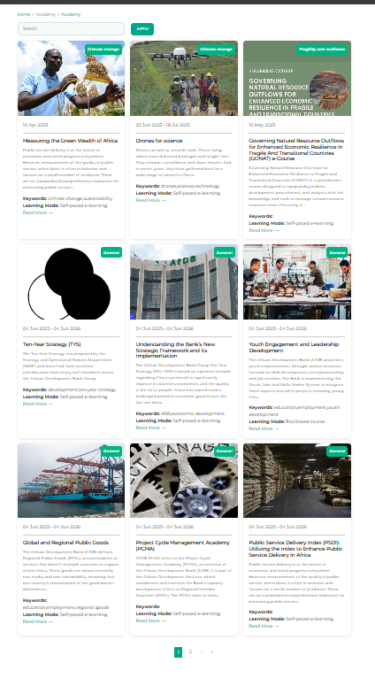

Tested Bite Learning and following are the issues:

- I am now able to upload a video to the Bite Learning – But the catalog page lists some youtube and doesn’t display it. I did not add any youtube video in the bite. The link I created is Building Capacity in Fragile Contexts: Voices from the Frontlines | Welcome to Virtual Capacity Development Academy
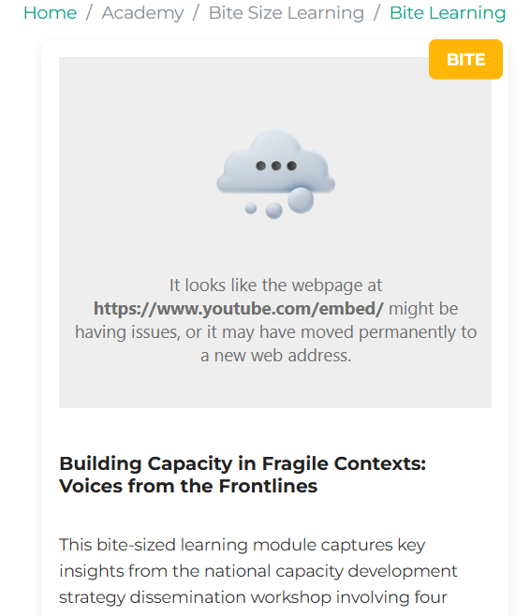
- The vimeo video that I setup up plays well in the bite page. The errors are only in the catalog listing page
- When I tried to upload a PDF document to a Bite I get the following errors:
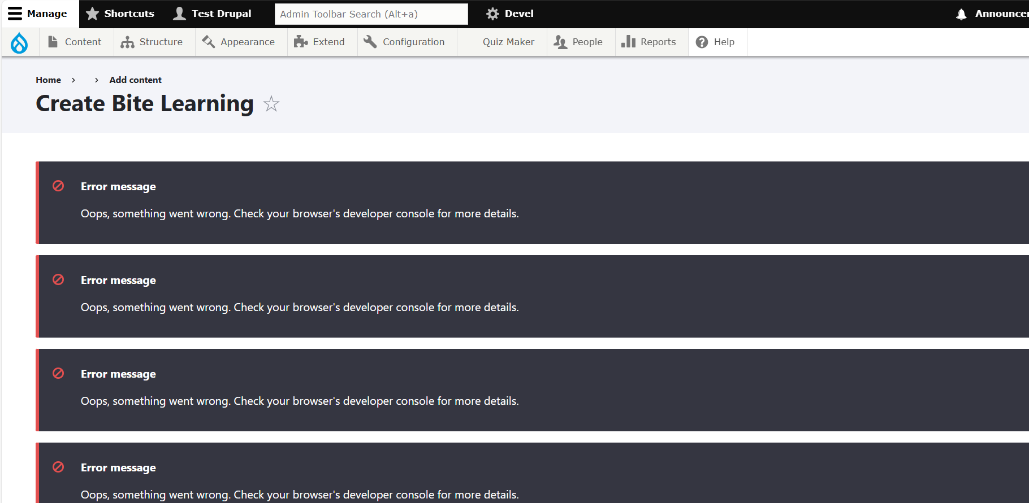
- Many times while testing the following error message keep showing up
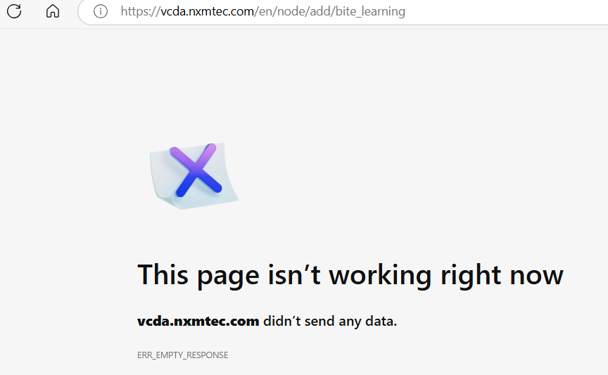
- When clicking on Add media for the first time the following error shows
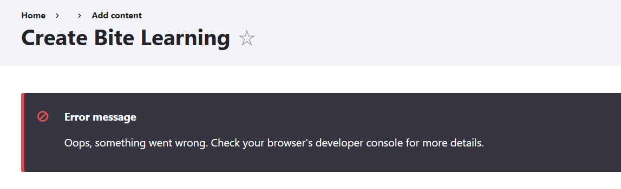
- During Document upload the grid doesn’t show the title. View is restricted as you can see below:
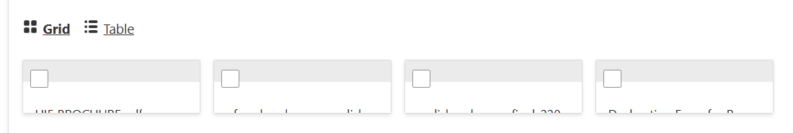
- When I select and insert a PDF document to the Bite it show below error. Thus unable to create and test a bite with a PDF resource
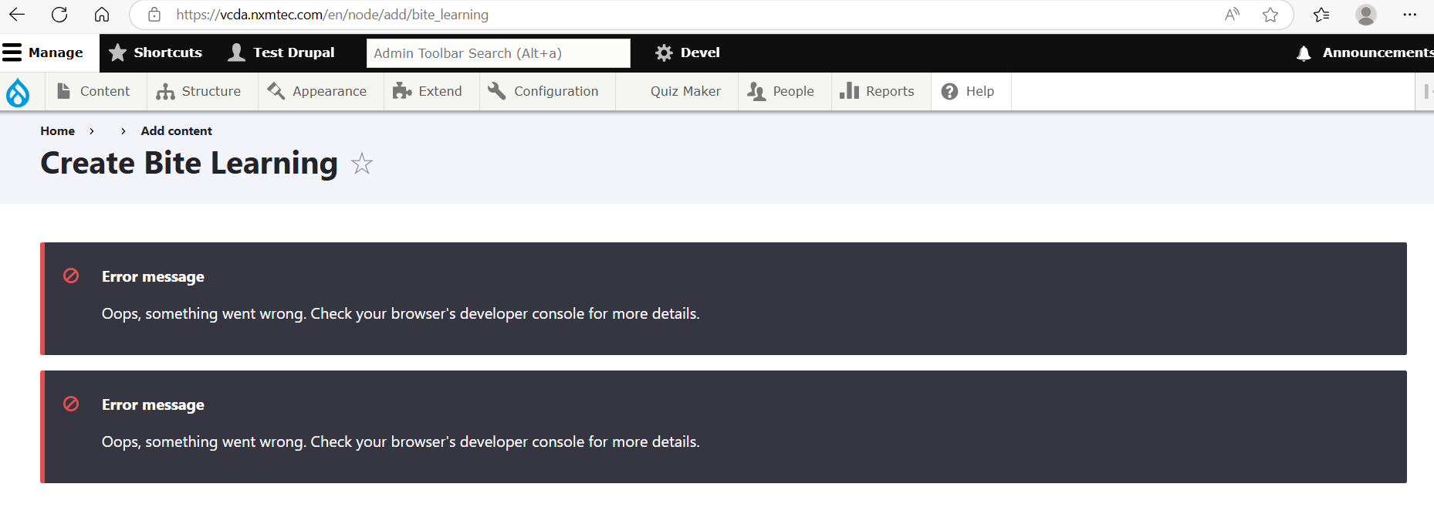
- The name of the MP3 chosen is not displayed and is hidden. Please fix
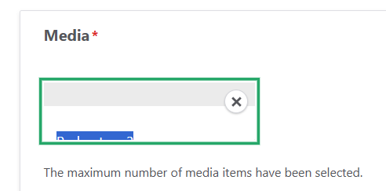
- On saving the bite the below is display. Please improve the visibility of the text in this panel as its not readable.
- I created a bite with a MP3 resource as podcast. The display is as below. There must be a default image that displays for Bites with MP3 or PDF resource. If image or video we can show the same but for other two we must have a option to show a defalut image
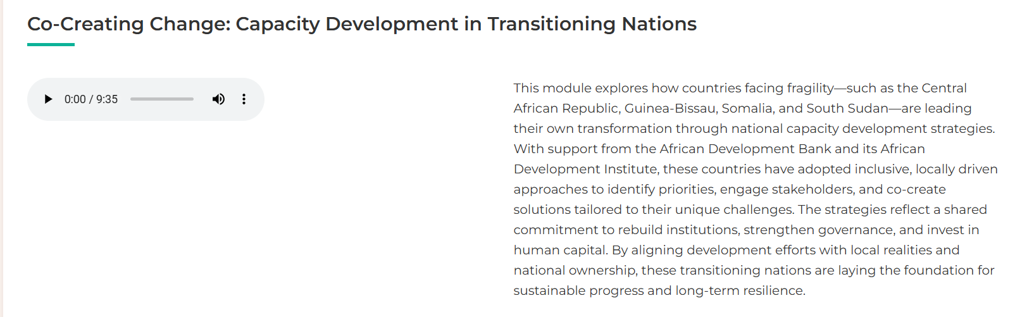
The full bite page looks as below

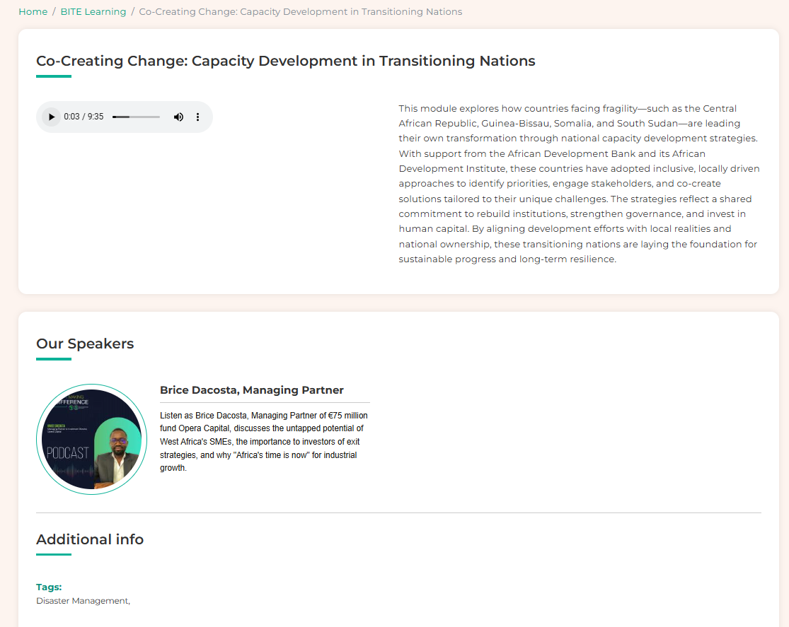

- During preview mode the following panel is displayed. The height can be reduced and the panel can be made to look better.
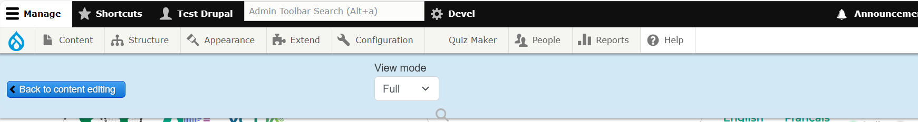
- Cannot understand the purpose of this search box on the bite creation page
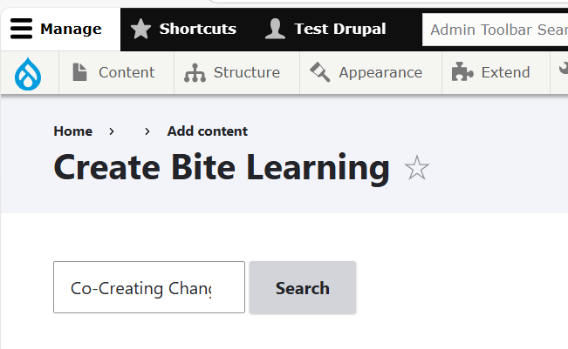
- Please make both Bite and Bite+ be listed in same page. They can be tagged on the thumbail to show if they are Bite or Bite+ learning like how they are tagged

Comments on Ask the Author

- When I click on Marketplace it displays a page as below. But I don’t have access to both this link. Make sure to display this page only for those who have access
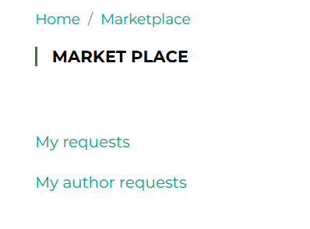
- When I am viewing a report I am able to see the authors under the report. But the filter above the author list is not working
- Not sure why Report title is a field in this filter? Is it requried?
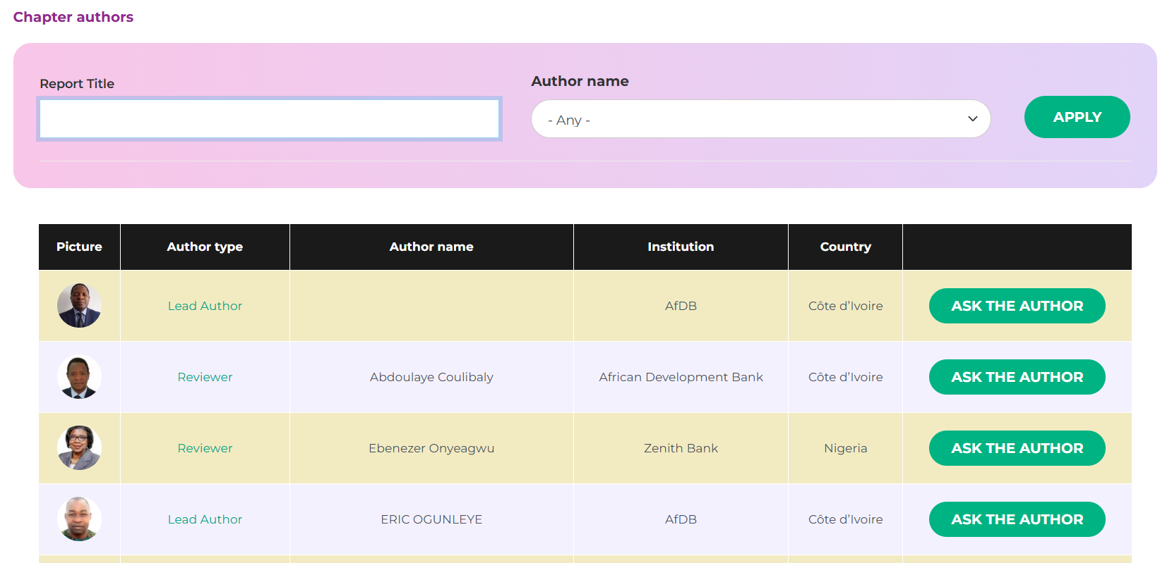
- Even when I choose a author already in the list and click on Apply it returns as No data. So I don’t see the need for this filter
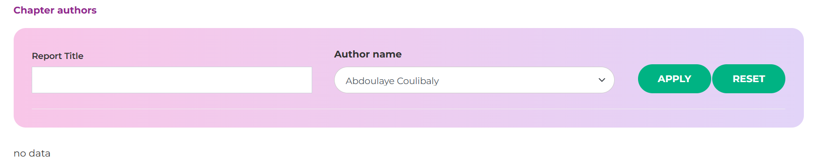
- When I click on Ask the author it shows - You are not authorised to access this page. All VCDA users must be able to ask questions to the authors or to the experts. Please fix.
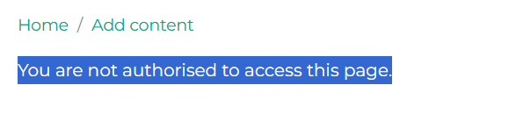
- I tried the same Ask the Author in the Author login provided. I am able to post a question and also respond to it using the same Author login. Shouldn’t the question go to the person I select to ask the question to? Please check if the work flow has been setup accordingly.
- When posting question the question page displays as below. Please improve the design of this page.
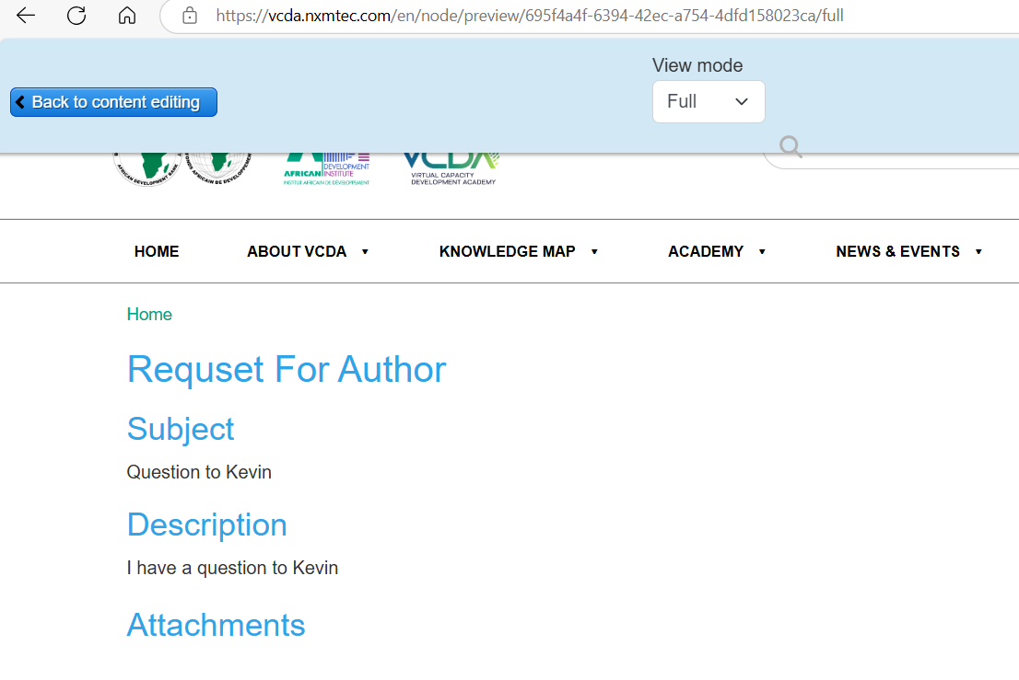
- Suggest remaining to “Question to Author” instead of “Request for Author”
- On saving I see as below. Please fix text visibility
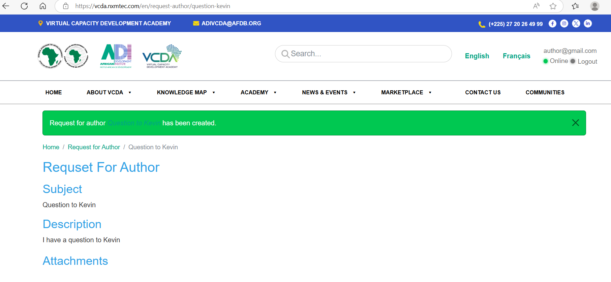
- When responding to the question and saving I see below page
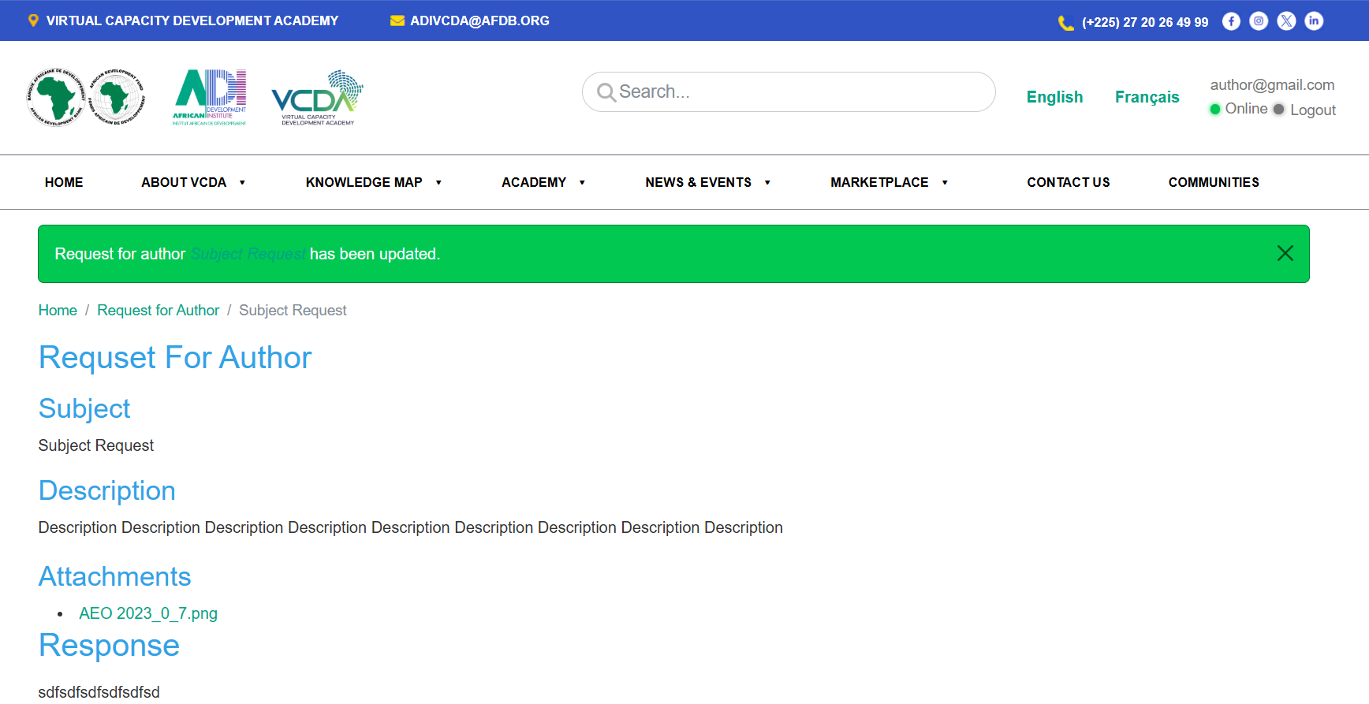
- Improve the design of this page also
- For me to test this again. Please provide a user login who will post the question and then a author login who will receive the question and respond to it. This way I can test both ends and confirm this functionality is working well.
- How the user knows the question has been responded by the Author? Are there notifications?

Comments on Ask the Expert

- I was able to access the Ask the Expert page in my login and submit the question. The follow page show when I submit or preview. Please improve the design of this page. This should be called “Question to Expert” instead of “Request”
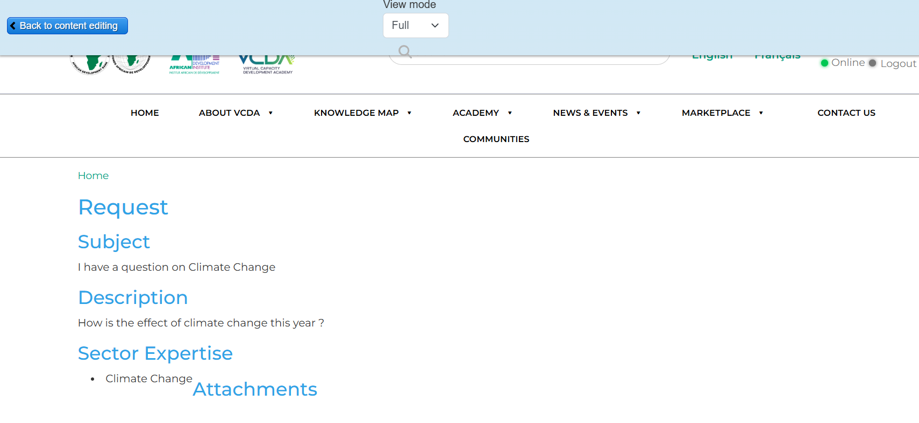
- On clicking the submit the following page is displayed
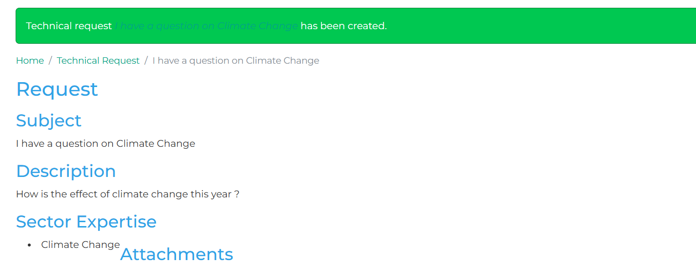
Change the design of this page: Visibility of text not there and also re align to display clearly.
- For me to test this again. Please provide a user login who will post the question and then a expert login who will receive the question and respond to it. This way I can test both ends and confirm this functionality is working well.
- How the user knows the question has been responded by the Expert? Are there notifications?
- I logged in with the Expert login. I am able to respond to all expert questions and also to all author questions. Is this correct? Only questions directed to the respective expert he should be able to respond?
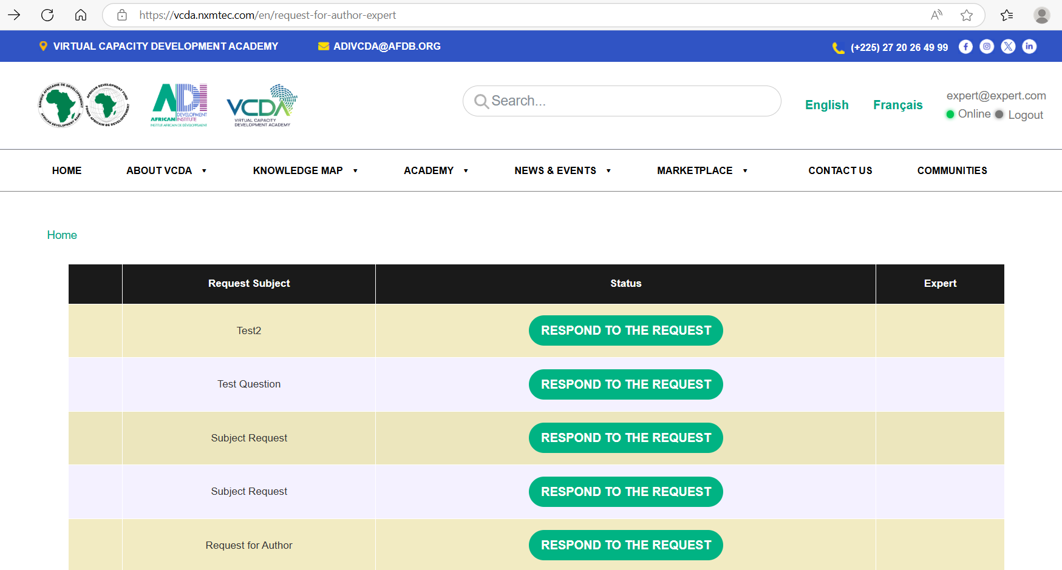
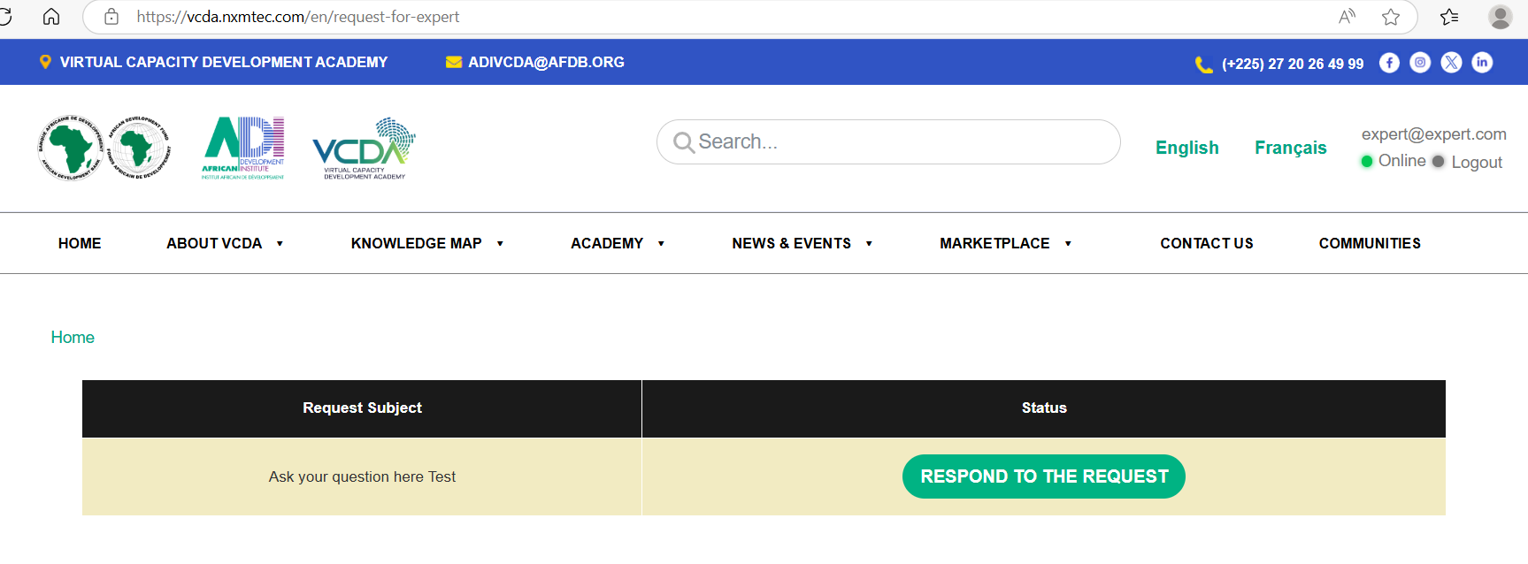
- After submitting the response the following page appears. Please fix the design of the page to show the question and answer in more visual layout
- 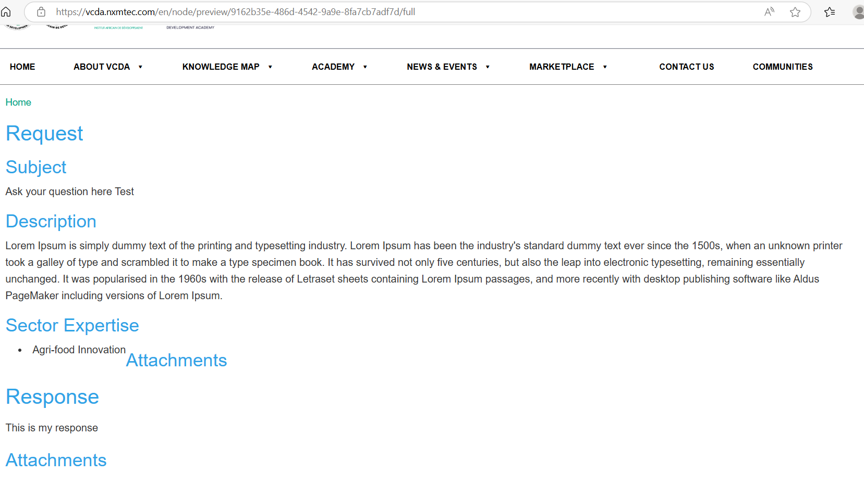
- On saving following page is displayed. Pls fix design of this page also
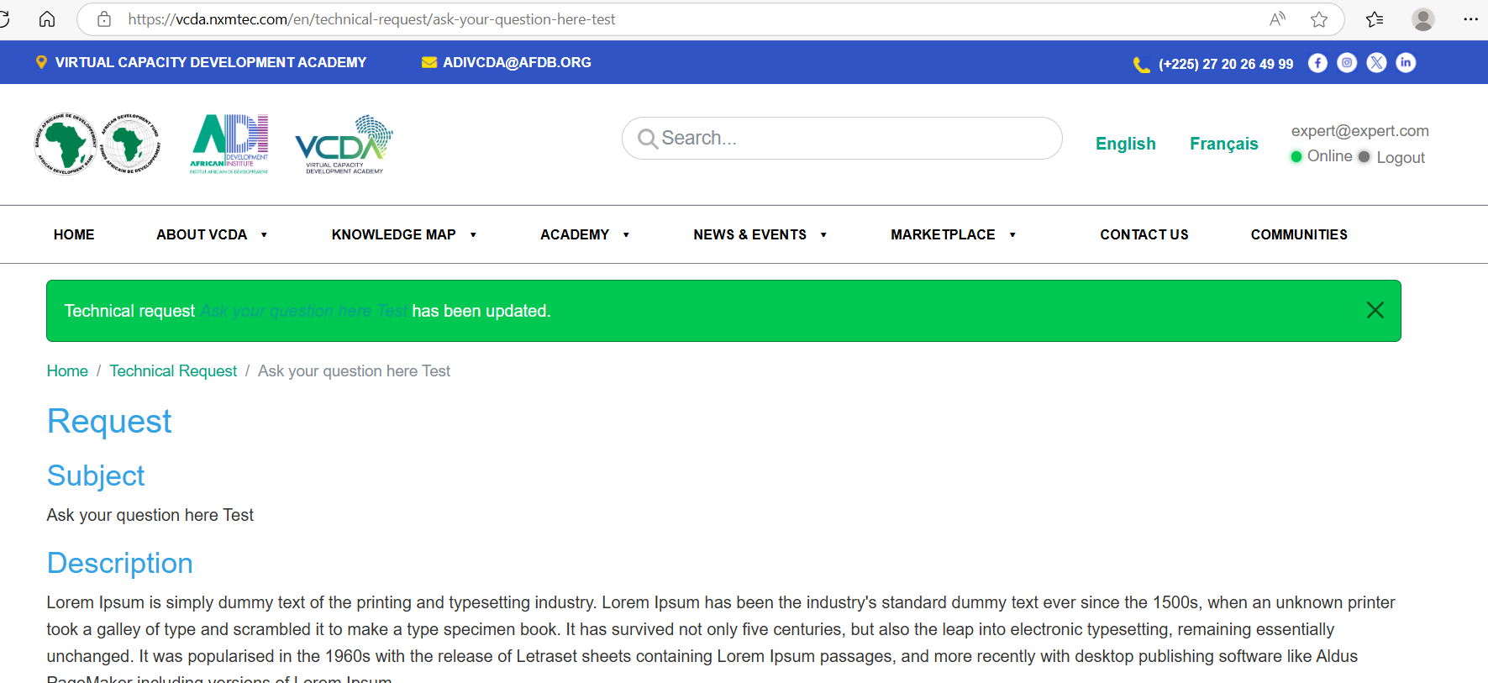
- Check the breadcrumbs also and fix as per the function
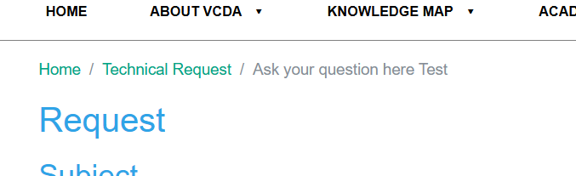

======== Comments to be fixed on https://vcda.nxmtec.com/en - 12th June ==========

Question 1- I already said in many of my earlier comments that we are not able to add video to Bite Learning. Only one image upload is allowed. Is this what is expected?
Previous comment from 24 April : The bite page will also showcase a single video or podcast. I don’t see an option to show this media element in the design. Please make provision. If the image area will be used for the media element then it must be made bigger and more prominent.
Answer - Done. – Checked and reported issues above

Question 2- After login the header section of the page is not designed fully. Screenshot below. The search, login name and Online and Logout can be aligned to the right. The logos should be properly aligned.
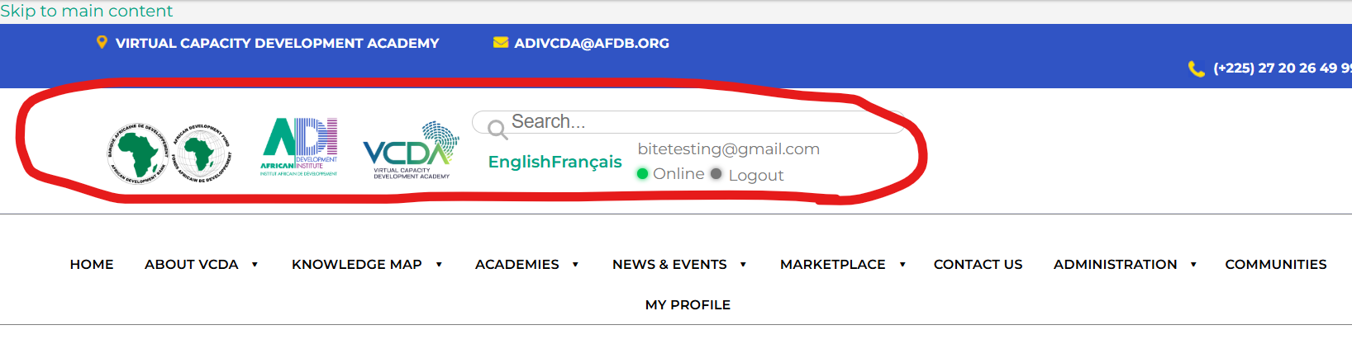
Answer - I checked this in multiple browsers. We didn't get this issue, May be it will occur when Page is not loaded properly so once we will migrate on bank's server it will work as expected.- seems good now

Question 3- The search results page is not designed or aligned properly. Should improve the UI for this page.
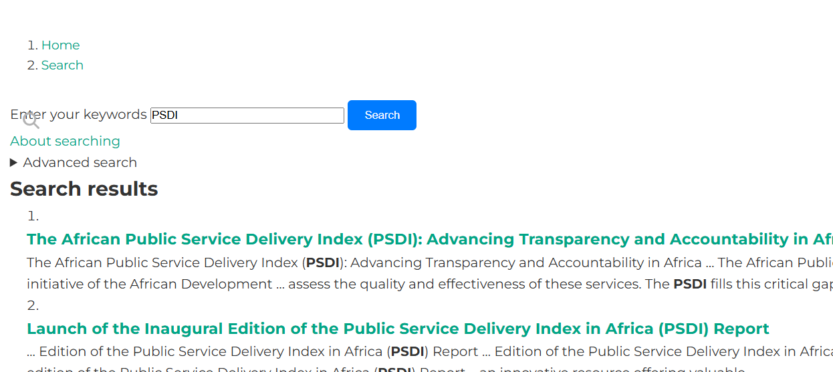
Answer - Done, If you have any other suggestions please let us know so we can change accordingly. – This is better

4 A - Developer console error shows on page while uploading media. The error message keeps appending at the top but is not visible to the user."
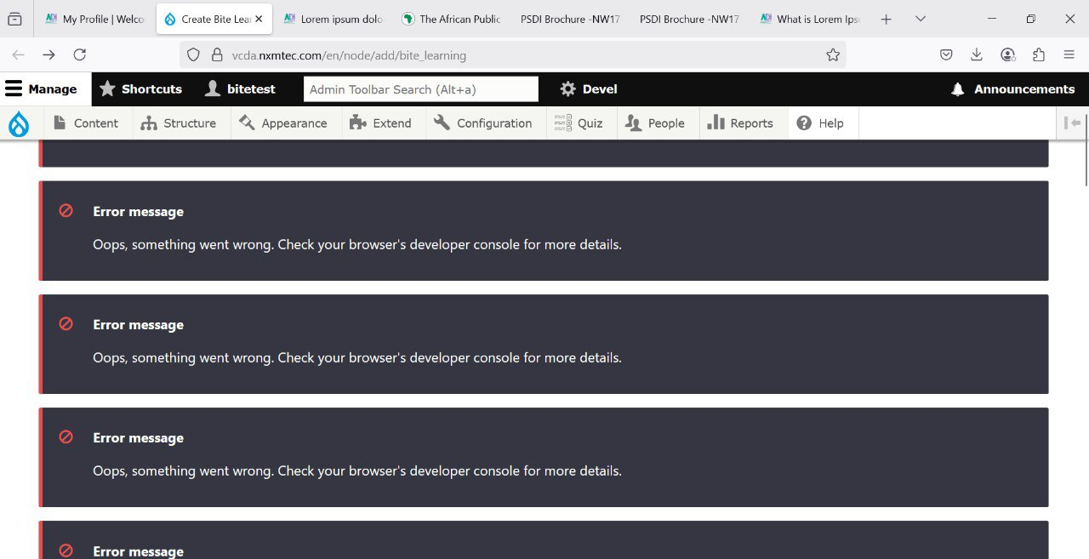
Answer - It's only on this server. when the site moves to your staging server, it will automatically fix itself. Because right now its on shared hosting.- ok will test in staging server again

4 B - The media file uploaded must be resized to the required maximum size for which the display form is designed and displayed in the form. For now it displays the image in its size.
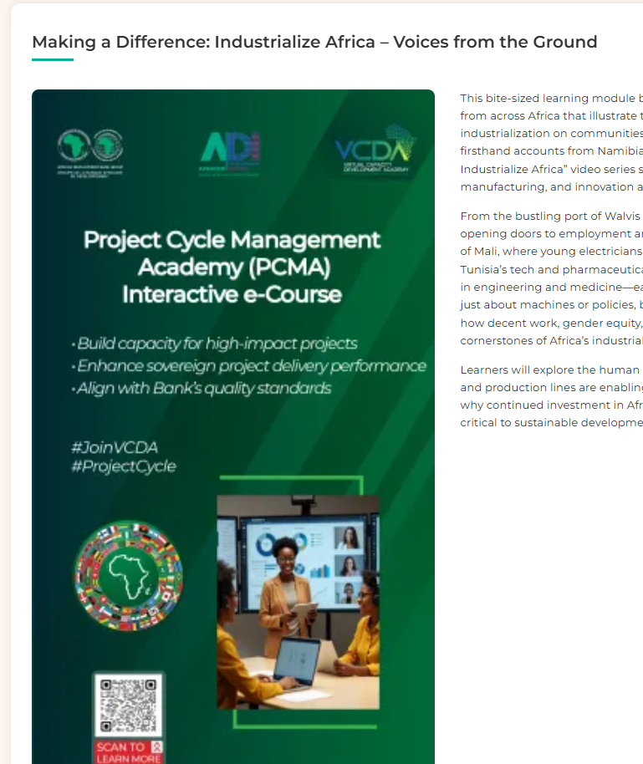
Answer - We have removed CSS for height and width and added Image style - Large (480×480) - ok

Question 6- Bite + : https://vcda.nxmtec.com/en/node/add/bite_plus_learning
A- File upload is not working unable to upload any kind of file / image file
Answer - Checked – File and image upload are working fine. – Ok

B- For the media element we must be able to add the embed code also directly as option to the URL (Like Resource page)
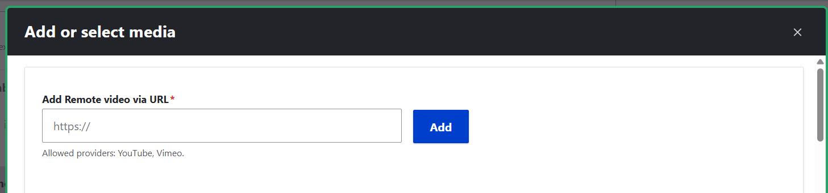
Answer - As per the requirement(Media field – video,audio podcast, images etc.)
Answer - Done, now you can upload, Image, Video, File. – Ok tested and issues reported above

C - Add media is not working in the create form but it's working in the edit page.
Answer - It's working.- Ok

D - We are able to add one multiple choice question. Cannot find option to add say 2-3 questions.
Answer- Now you can do as much as you want. Ok

E - Bites included remove button doesn’t work sometimes.
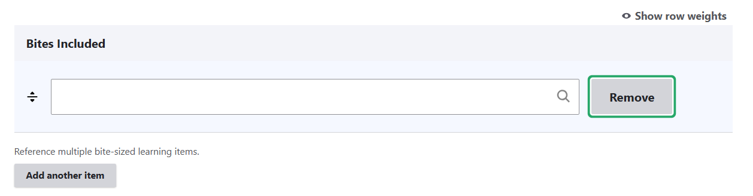
Answer - It's only on this server. If the site moves to another server, it will automatically fix.-Ok need to test again

F - Resources section should display the added PDFs or external links within the area with wrap text. There need not be an embed code option provided for Resources. This is how it is displayed if added. This needs to be fixed.
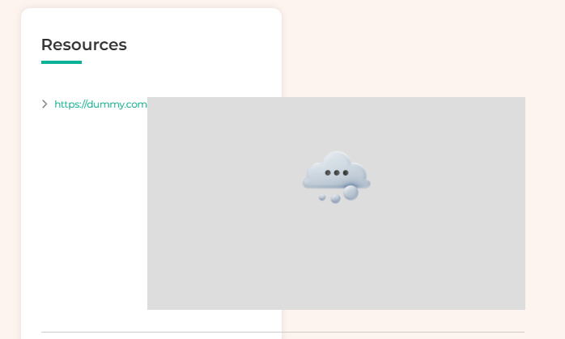
Answer - Done. - Ok

G - Why is there an upload image section below bites included, where will this display ?
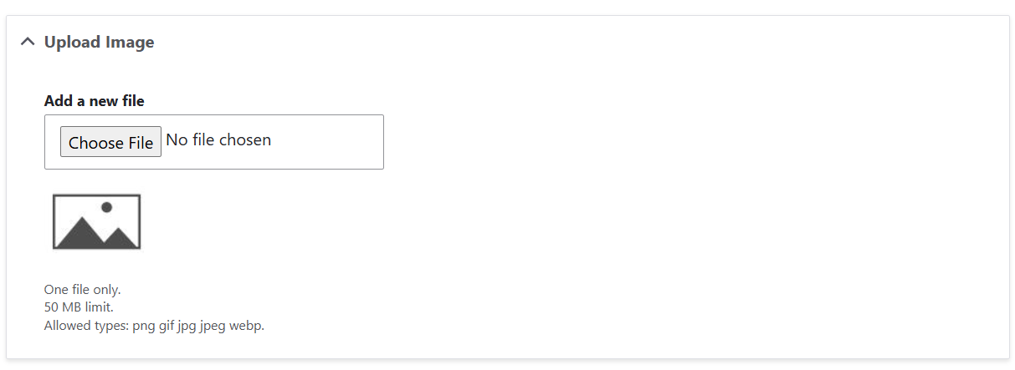
Answer - Removed. - Ok

H - The video should be displayed in a Carousel. Now they are only listed one after the other. Unable to add a third video to test.
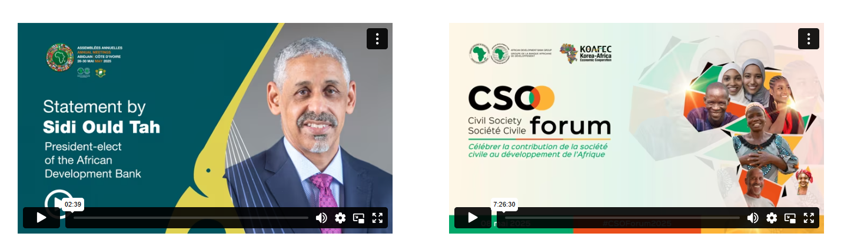
Answer - Already working. Please let us know if you face any issue.- Carousel is displayed now but it not possible to change. Same content is shown in all three carousel

When bites within Bite+ are listed, note should added below it - Click on each Bite for more information
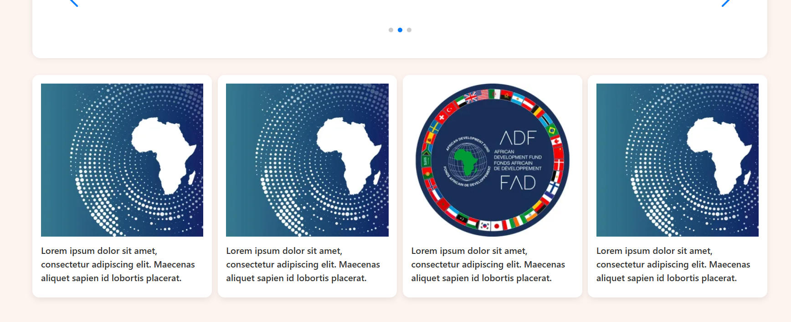

J - Resource Label is not displayed anywhere. Only the PDF file name uploaded is displayed.
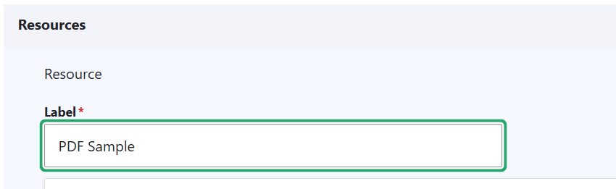
Answer - Done.- OK

K - Multiple resources should be able to be added to the Bite. Currently only one is allowed.==
Answer - As per requirements we can't add resources in Bite, We can add multiple resources in Bite Plus that is working properly. if you want please let us know we can do that. .- Yes multiple resources we should be able to add to Bite also

=========Comments to be fixed on https://vcda.nxmtec.com/en - 16 June =========

1. Knowledge Map – Map feature used throughout the site is not working as in tihe original site. On clicking on any country the list of resources should be shortlisted to show only the clicked country. Check on this page
https://vcda.afdb.org/en/regional-knowledge-resources?field_regions_tid=22#amchart_container
Answer - Done. .- OK

2. On clicking on breadcrumbs – Home – makes the menu smaller first and then it becomes larger. There is a jerk on screen. I think can be fixed
Answer - Done. Please let us know if you need other changes in this. .- OK

3- In the speaker page https://vcda.nxmtec.com/en/eminent-speakers - The name of the person must be the one that is bold and under the photo. Now some other title is displayed and it all appears as similar to the other.
Answer - Done, Please note Title is coming from data which is coming from Drupal 7 and we have added name of speaker but this is not clickable as this is in body part content, we did as per the content of Drupal 7. – Please change to only Name to displayed in speaker page
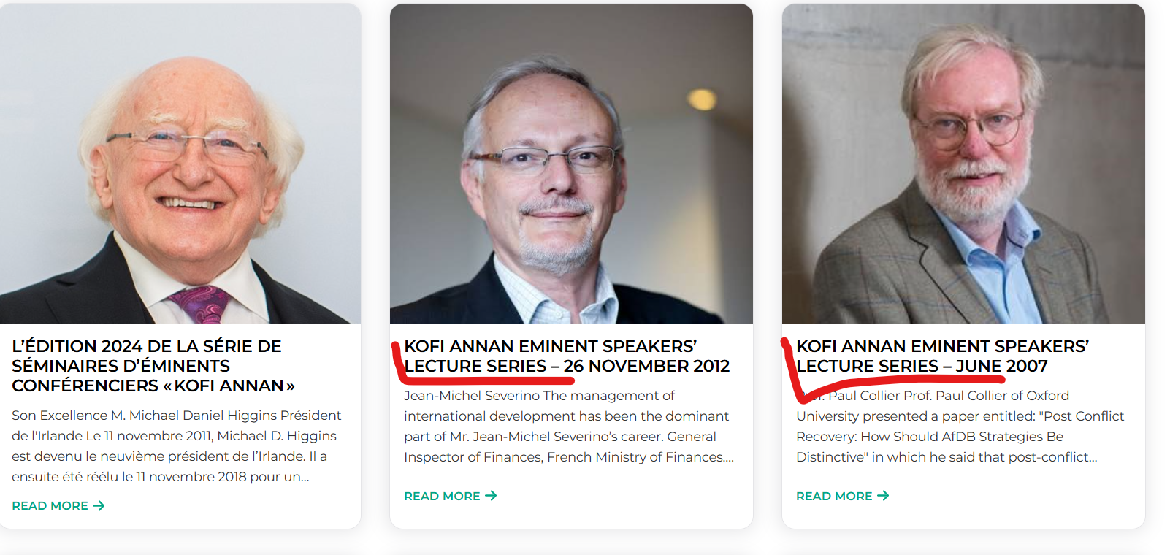

4- Area of Work and Learning Preferences drop down has not been updated with latest same list.
Answer - Already Done. Please let us know if you need other changes in this. .- OK

5- On clicking Sign in highlighted is not added
Note for Staff: To access the Virtual Capacity Development Academy Platform, please use your Active Directory credentials.
Answer - Text is already added there, Do you want to change anything else over here so please let us know.- .- OK
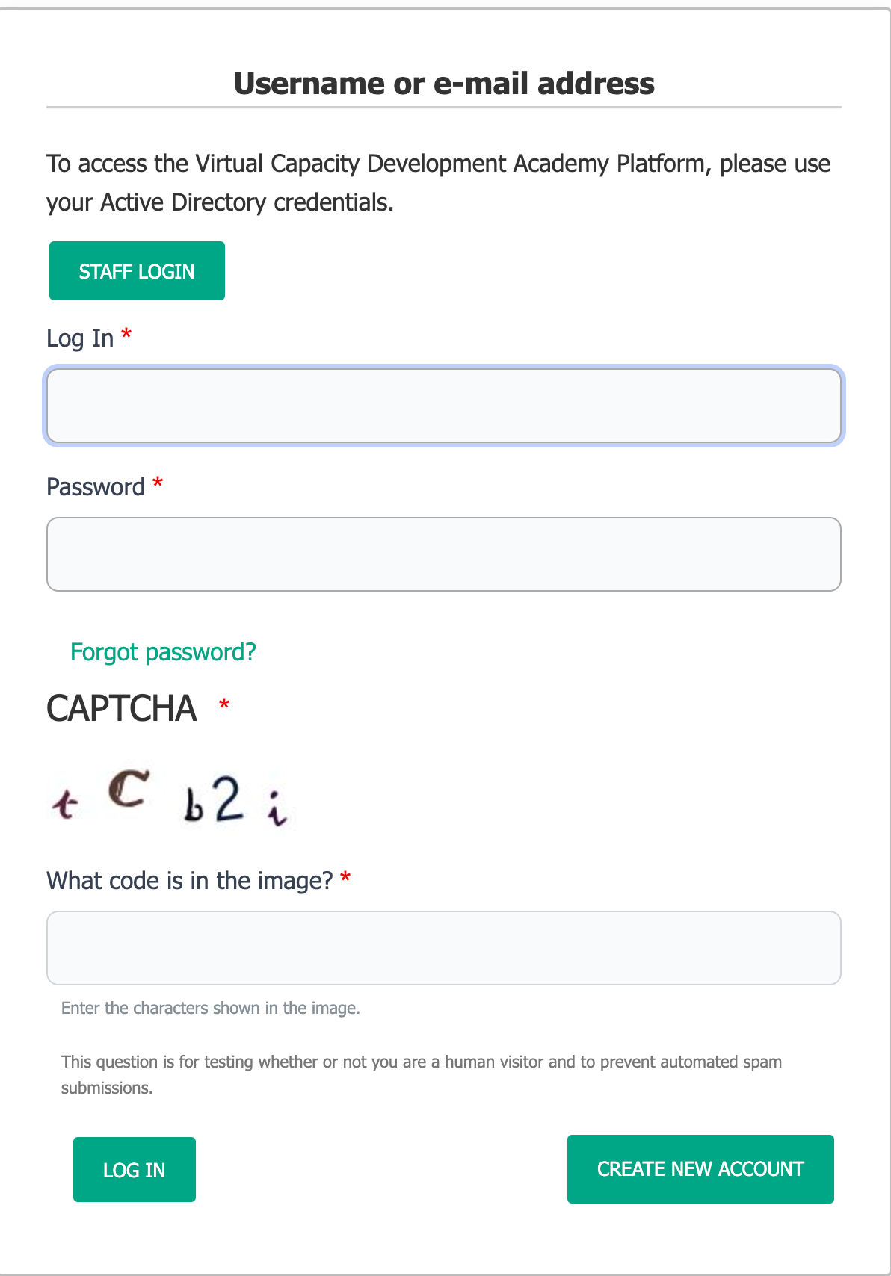

6 - Text are design of this section can still be improved. VCDA can be made bigger. Sub titles can be in bold or different font. Spacing can be made to look better.
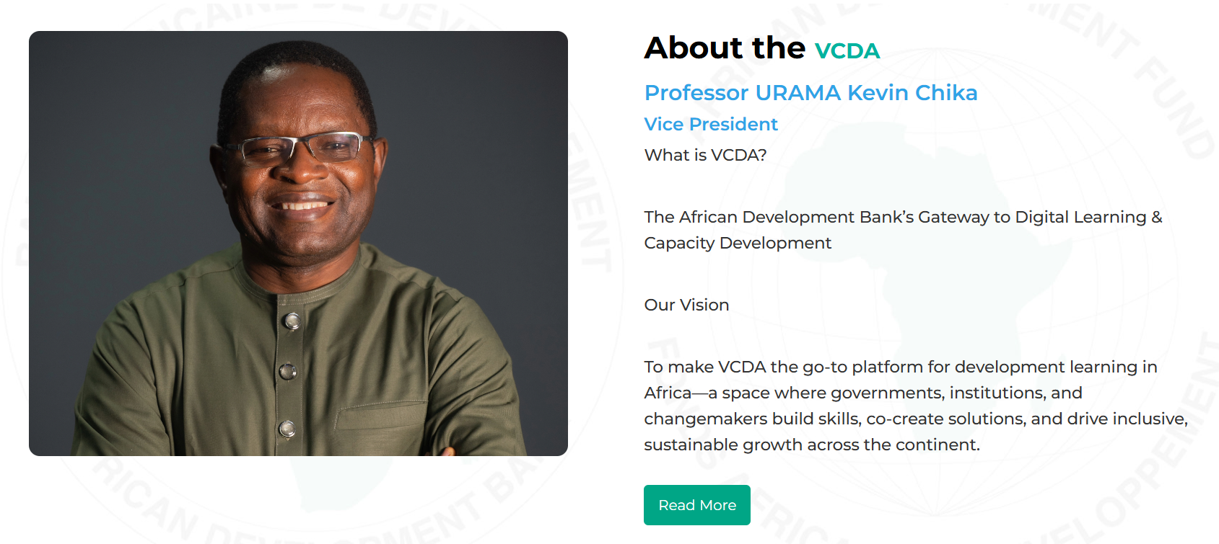
Answer - Done, Please let us know if more changes you want so we can do that. .- OK

7- Text formatting to be improved on this page also (bold the sub headings, space properly for good readability)
Answer - Done, Please let us know if more changes you want so we can do that. .- OK

8 - On clicking on highlights the same title appears thrice in different fonts and styles and sizes. This can be avoided. Same for News also
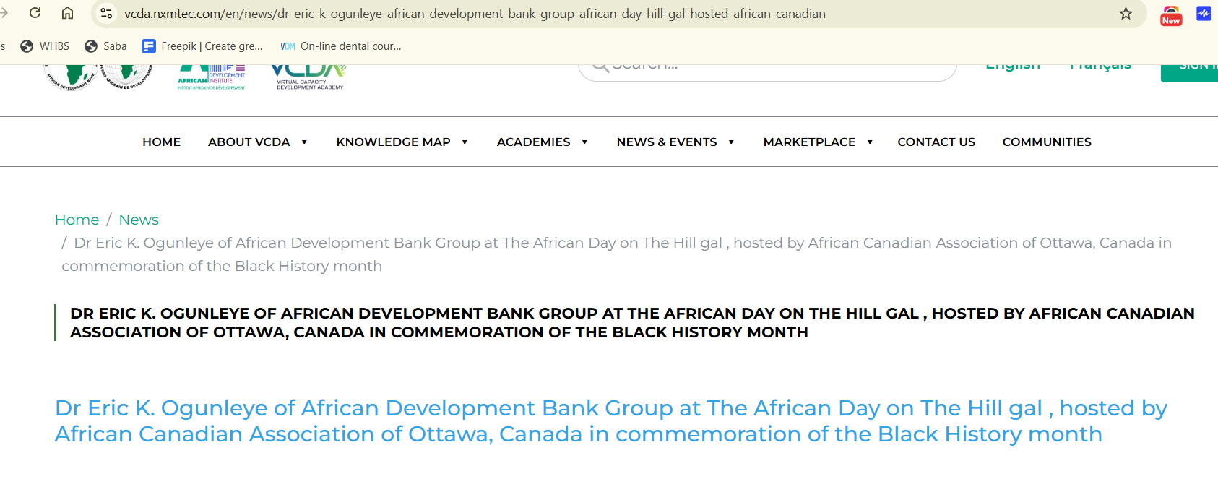
Answer - We have removed 3rd one, Now there is a breadcrumb and the 2nd one is Title. I think It’s fine because 1st one is Breadcrumb and 2nd one is Title. Please suggest if you need any changes here. .- OK

9 - Image size on this page can be made smaller for better readability
https://vcda.nxmtec.com/en/news
Answer - Done. .- OK

10 - Spacing in marked area can be reduced further for better page view.
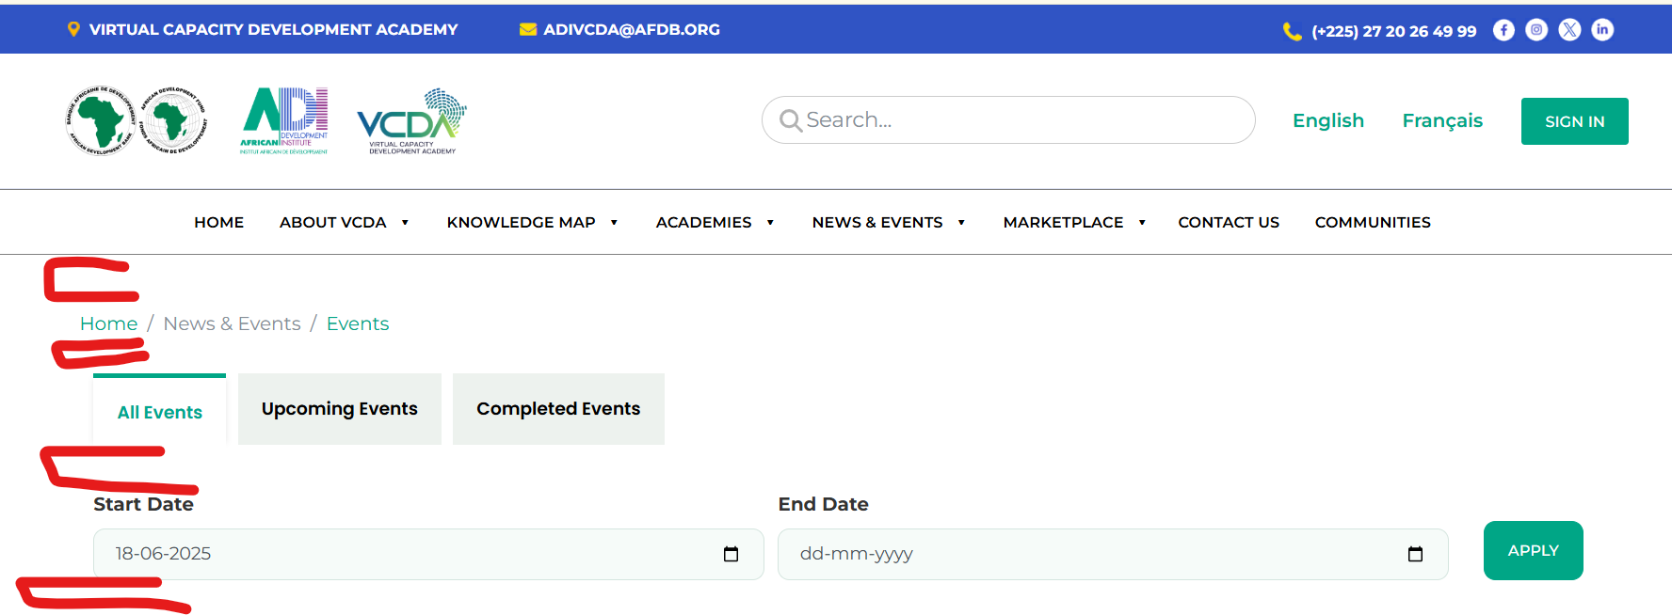
Answer - Done. .- OK

11- Popular video section – clicking on the video plays the video in the same page. Is this required or should it redirect to the specific page and start playing there.
Answer - If you direct click on video it will play there only and of you click on Title It will be redirected to details page and play there. .- OK

12- Clicking on Reports in footer leads to error page - This page lead to error Page not found | Welcome to Virtual Capacity Development Academy
Answer - Done. .- OK

13- Contact Us Page is not created or linked.
Answer - Done. .- OK

14- The Menu items should be changed from Academies to Academy.
Answer - Done. .- OK

15- Please provide login credentials to test the Ask the Expert feature
User = Expert Email = expert@expert.com
Password = Demo Tested and issues reported above

16- Clicking on the thumbnail should take to the respective page on this page https://vcda.nxmtec.com/en/policy-dialogues
Answer - Done. .- OK

17- Can the Policy Dialogs item page be better formatted with bold for titles and right pane for meta elements such as :
1.Type: Policy dialogues
2.Event visibility: Online
Answer - Done. If you want any other changes please let us know we can do accordingly.- Can this page also be designed with left and right pane so visibility and look of the page can be better

18 - On the report page the following section is displayed. Cannot find its purpose.
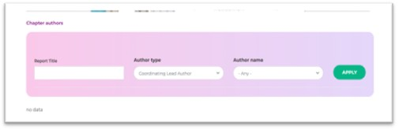
Answer- Please check this URL.
https://vcda.nxmtec.com/en/reports/policies-enhancing-resilience-and-transparency-public-and-private-financial-management-post - Issues reported aabove

19. - There must be an option to see all pages in English and French. This doesn’t seem to be the case now. When we change to French the menu items and interactions change but page content does change
Answer - We can read all pages in both English and French, Do you want to add french link anywhere else along with header? -.- OK

20- News date is not visible in the card view after filtering.
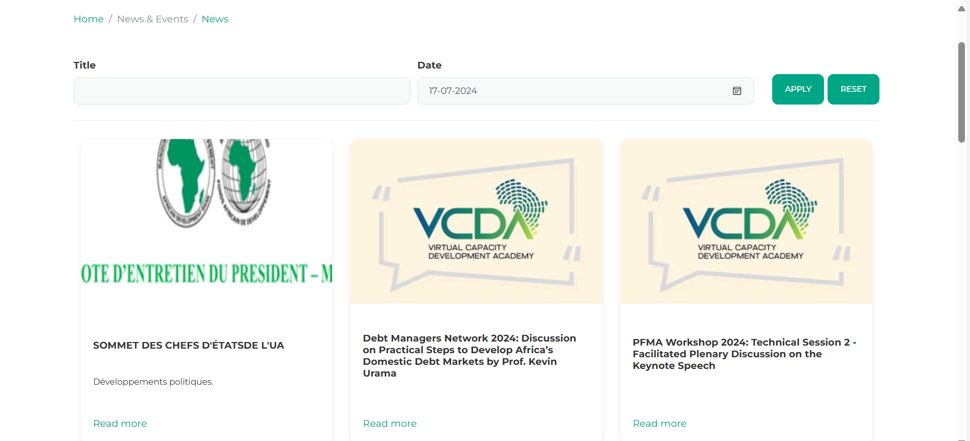
Answer - Done.- Date filter is not working

21- Getting error message while navigating to policies pageimage.png
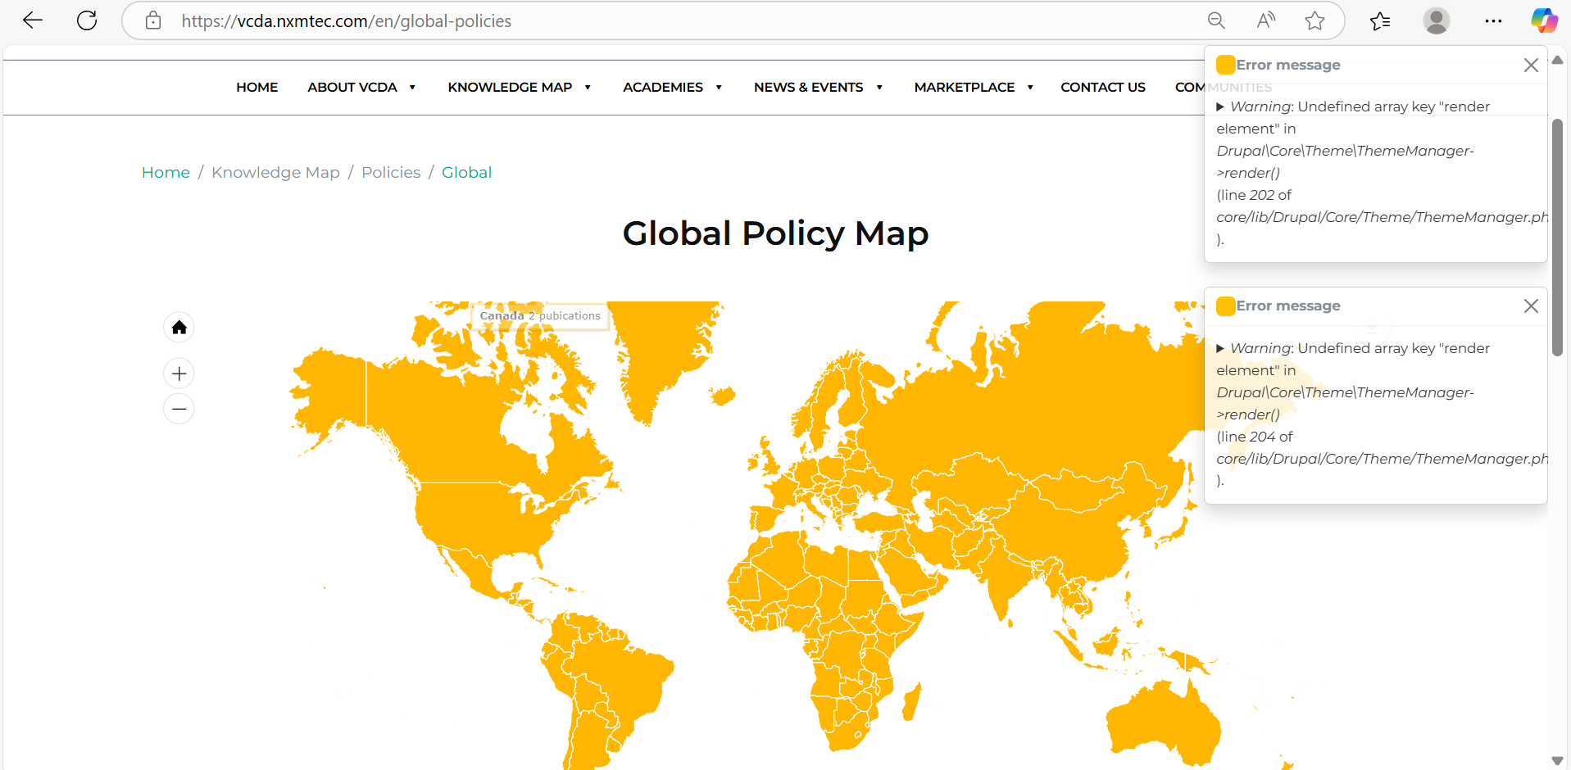
Answer - Done. Map is not displayed now. Pelase check
Global Policies | Welcome to Virtual Capacity Development Academy
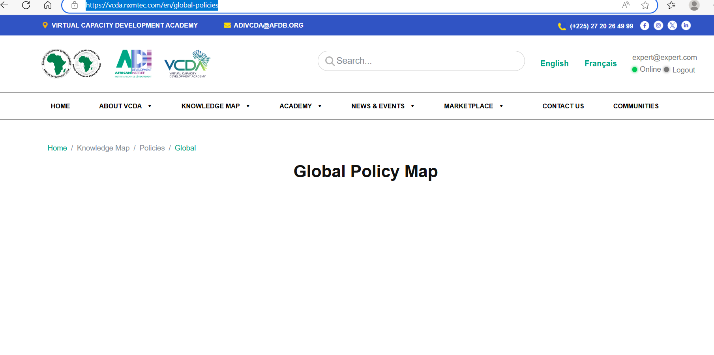
22- Getting error message for translation Click on translation button.
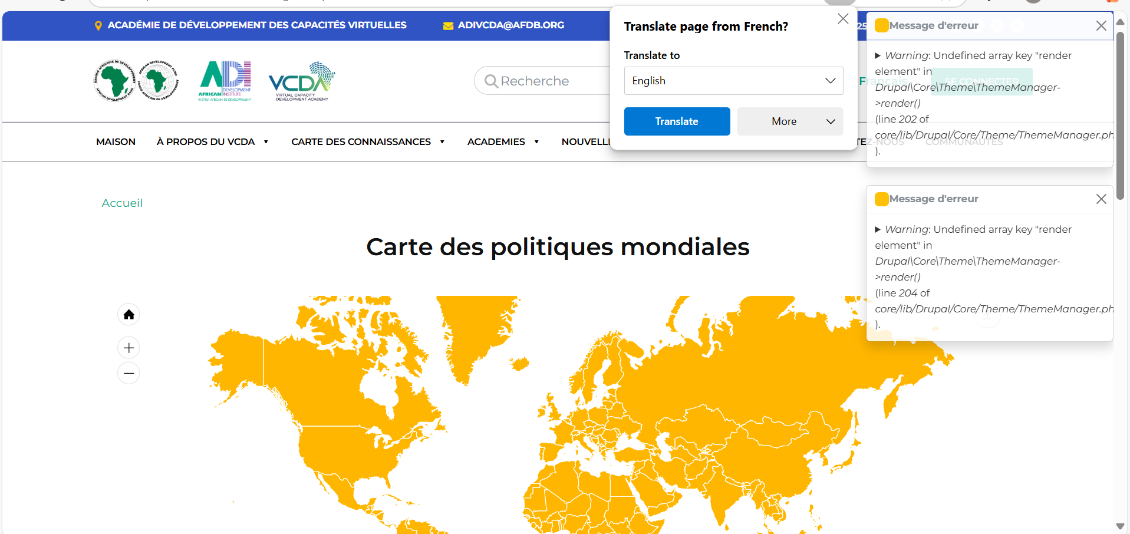
Answer - Done. -.- OK

23- When you minimize or maximise the page unable to view the Horizontal navigation bar
Answer - Done. -.-still not able to see the horizontal naviation bar in the pages that map appear. Please fix

